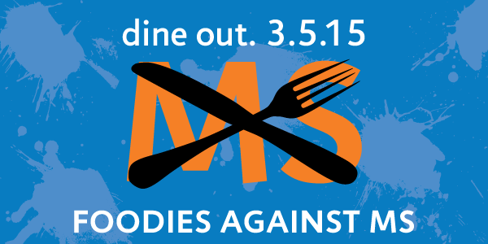

Come support the
National Multiple Sclerosis Society
Pacific South Coast Chapter
Foodies Against MS
March 5, 2015
11am-10pm

Participating Locations:
Cold Stone Creamery (La Jolla)
909 Prospect Street #225
La Jolla, CA 92037
Cold Stone Creamery (Poway)
14797 Pomerado Road
Poway, CA 92064

